**FASHION WORLD**

**Team06nov16**

**Submitted By:-**

**Team Members:**

**Gagandeep (jc353117)**

**Amandeep Kaur (jc443753)**

**Avneet Kaur (jc458519)**

**Harpreet Kaur (jc353332)**

**Under the guidance of:**

**LECTURER: CUE NGUYEN**

1. **Project Concept And Objectives**

Fashion is generally associated with textile, garments and trends. It is a normal for the fashion trends to change according to the seasons. Each season brings a particular colour and style. Fashion is followed by both men and women regardless of their culture, trends and ethnicity, however children are also aware and prefer to wear what is in fashion.

It’s a website that provides:

* What is new in fashion
* High Trend Standard quality

1. **Guidelines And Technical Objectives Of Fashionista Website**

* The main objective encompasses the basic idea of getting a glimpse of high end fashion and trends that of this website is to describe and analyse the fashion styles among people.
* Globalisation:- Democracy, media, and spread to other fashion centres make fashion available easily to the people.

1. **TARGET USERS**

* Teenagers
* Old-age
* Middle-age
* Children
* Everyone who loves fashion

Our site gives a look of the accompanying pages:

1. Home page: It gives a prologue to our administration where guest can investigate advance about our administrations.
2. Products: It shows our recommended products to all target users.

3) About: It gives a look about what we do and how we are spreading globally.

4) Registration: It enlists the new guest when he gives the points of interest.

5) Search: Enables client to scan for the favoured sustenance thing with value points of interest.

6) Login: This page will permit the current client to login.

Home page

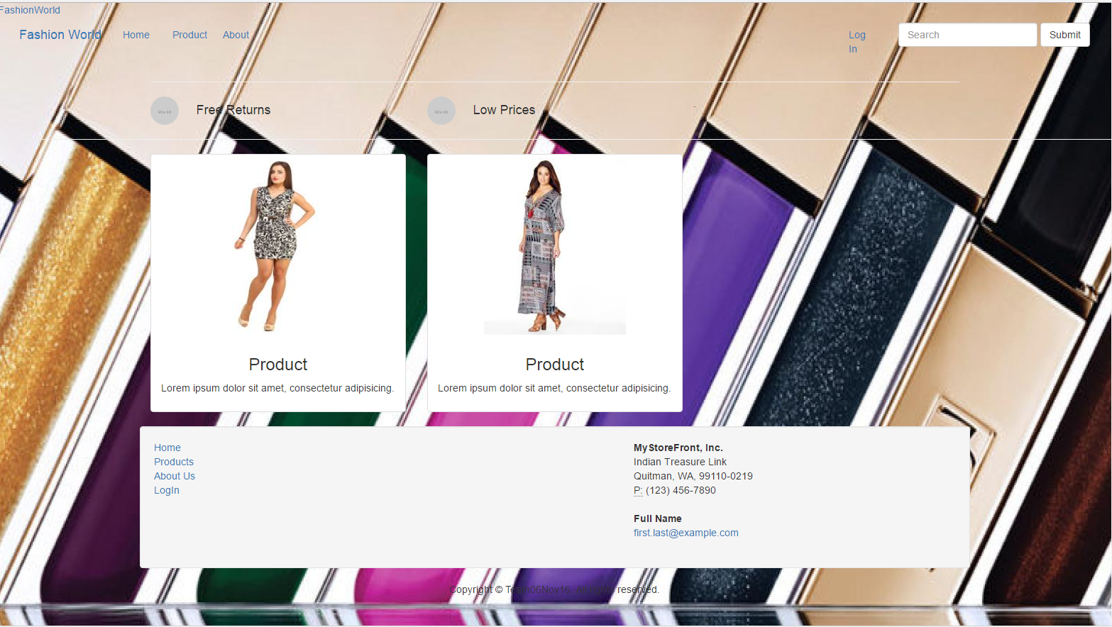

Products

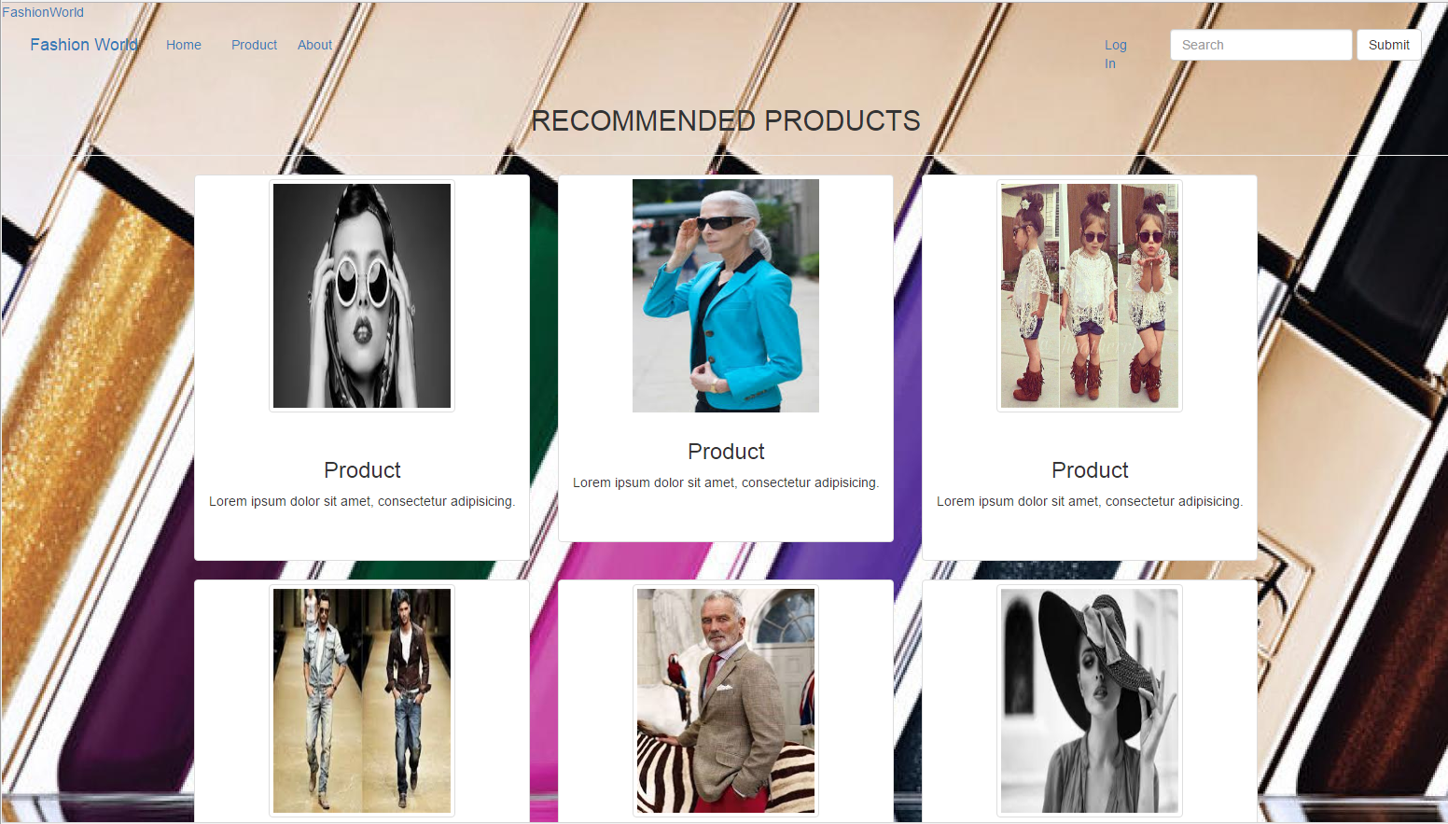

About

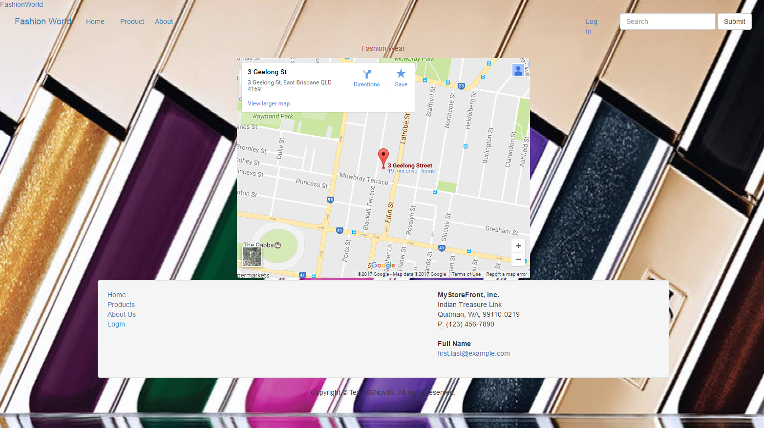

Login

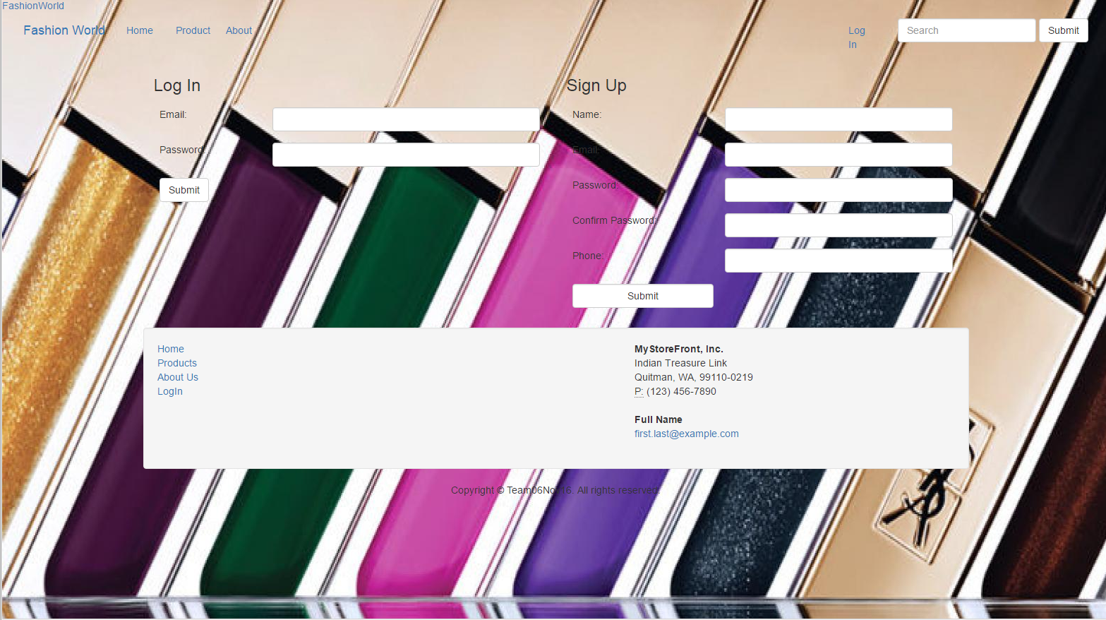

Search

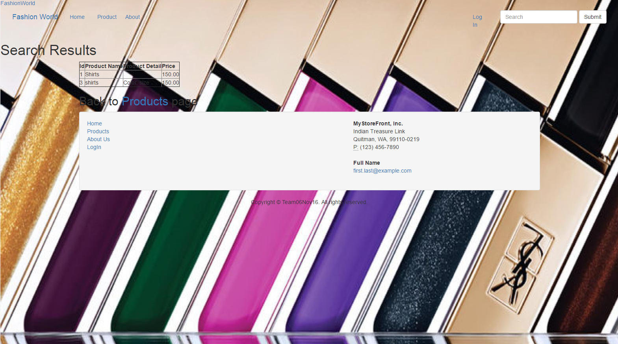

1. **Technologies**

* Front End: Dreamweaver/Notepad++, HTML, Bootstrap
* Editing Tools: Photoshop, Flash Player
* Back End: MySQL, PHP

1. **Responsibilities**

* Gagandeep Singh: Designing, data collection and coding of Home Page.
* Harpreet Kaur: php coding of products and search page
* Amandeep Kaur : php coding of users login, logout and registration
* Avneet Kaur: Designing, Data Collection of about Us Page and designing Of Home Page.

**Websites Blueprint**

**Blueprint**

Fashion World

Home Page

About Us

Products

Search

Login

Sign up

**2)Web Pages**

**Home Page**

**Sign up**

**Login**

**Search**

**Product**

**About us**

**3) Web site access Link**

**10.250.0.9/team06nov16/ProjectFinalStage/index.html**

**SCHEDULE:**

* Basic approach:
* Home page design – week 5
* User features – week 6
* Designing of pages – week 8
* Complete project – week 10